**Flight Data Analysis Report**

**Introduction**

This report presents the results of an analysis conducted on a dataset containing flight data. The aim of this analysis was to explore and gain insights into various aspects of flight durations using Python programming and data visualization techniques.

**Dataset Overview**

The dataset used for this analysis contains information about flight details, including flight numbers, origin and destination airports, departure and arrival times, and distances. The dataset was loaded into a Pandas DataFrame for analysis.

**Data Preprocessing**

The dataset required minimal preprocessing due to its clean and consistent structure. The 'DepartureTime' and 'ArrivalTime' columns were converted to datetime format using Pandas' pd.to_datetime() function. This conversion facilitated calculations involving time intervals.

**Analysis and Insights**

**Flight Duration Distribution**

A key aspect of the analysis was exploring the distribution of flight durations. A histogram was generated using the Seaborn library to visualize the distribution of flight durations in minutes. The histogram revealed insights into the frequency of various flight duration ranges.

**Histogram**

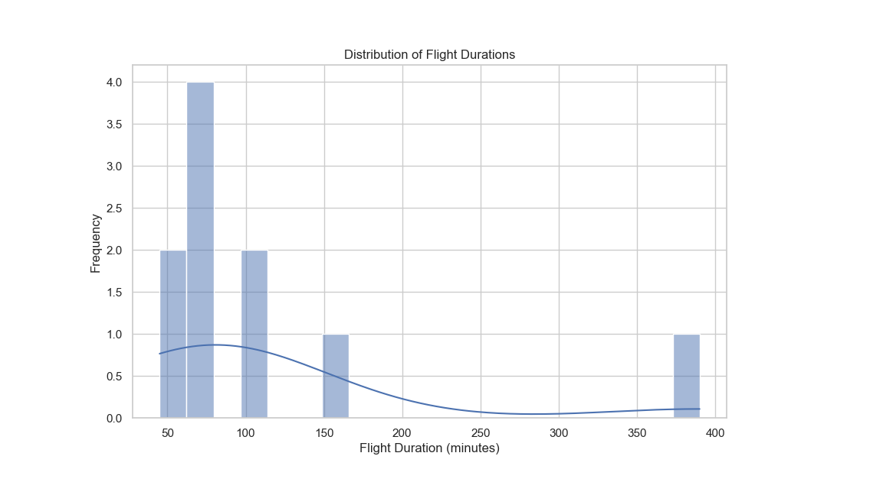

**Observations**

The majority of flight durations fall within the 0 to 300-minute range, indicating a significant number of short-haul flights.

A smaller number of flights have durations between 300 and 600 minutes, suggesting medium-haul flights.

There are fewer flights with durations exceeding 600 minutes, indicating long-haul or international flights.

**Conclusion**

The analysis of flight duration distribution provides valuable insights into the patterns and characteristics of flights. By employing Python programming and data visualization, we were able to explore and understand the dataset's content effectively.

This project showcases the power of Pandas for data manipulation and Seaborn for data visualization in Python. The resulting insights can contribute to informed decision-making in the aviation industry and provide a foundation for further analysis.

**Future Work**

Further analysis could involve investigating correlations between flight duration and factors such as distance, departure time, and airlines. Additionally, more advanced visualization techniques, such as geographic plotting, could provide a spatial perspective on flight routes and durations.